The Routledge Encyclopedia of Modernism

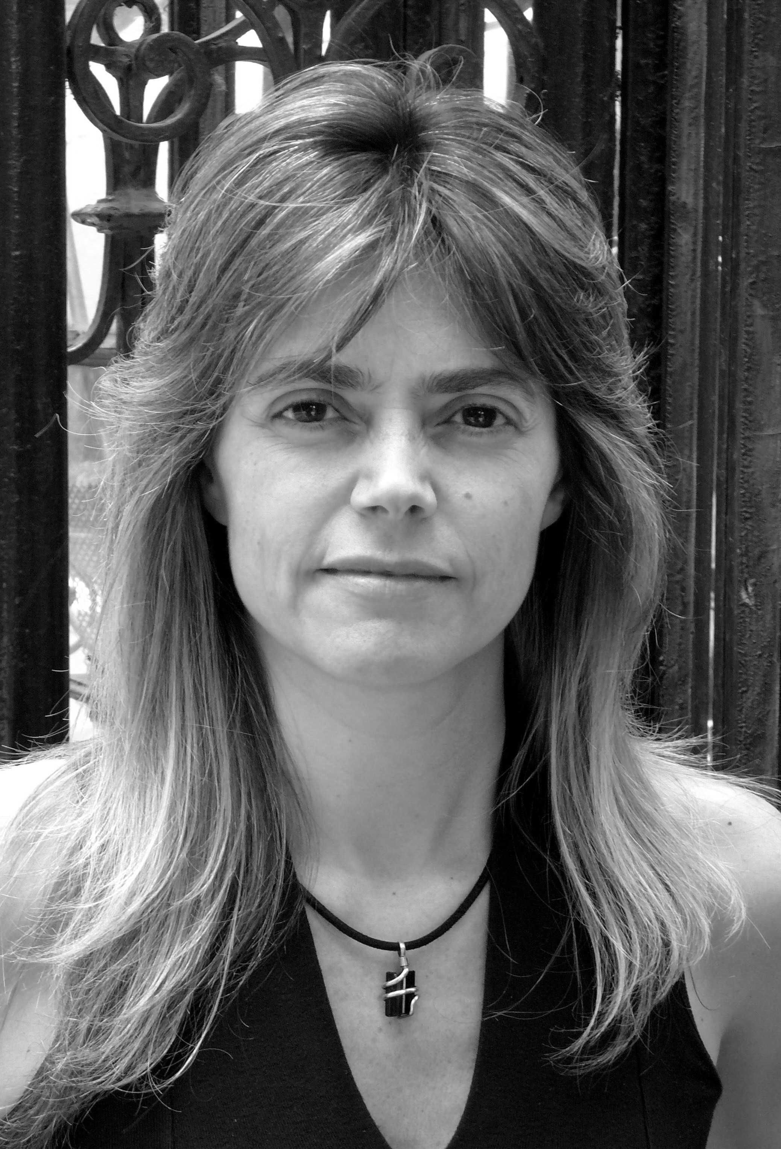
María Cecilia Villanueva. Foto: Mariano Etkin

María Cecilia Villanueva (1964)

Born in 1964 in La Plata, Argentina. Studied composition at the Universidad Nacional de La Plata, with Mariano Etkin, where she currently works as teacher in composition and researcher in musical analysis focused on 20th century music. She is considered one of the most notable personalities of her generation, successfully mixing research and composition.

Her music is a testimony of aesthetic independence, distinguishing itself from that of her colleagues by the originality of her technical approaches and the realization of very personal ideas. The expressive density of Maria Cecilia Villanueva’s music develops around a complex elaboration of materials, which in some cases, coexist with elements of extreme simplicity. Her music has been performed in the main festivals and new music cycles of Europe, U.S.A. and Latin America, having received multiple recognitions, such as the German Forum Junger Komponisten 1989 (WDR) prize in Köln and the Elizabeth Schneider 2001 in Freiburg, as well as the Premio de la Ciudad de Buenos Aires, Argentina, 2003. She has been the recipient of several prestigious German composer residences such as the Akademie Schloss Solitude, Stuttgart (1994/95); the Künstlerhof Schreyahn (1996) and the Künstlerdorf Schöppingen (2003).

In her musical output, each work appears to be its own world, closed in itself, and full of tension. In general, the instrumental writing is decisive in terms of the determination of its constructive characteristics, the selection of the sonic material being used, and its relation to the overall form. All of these characteristics are evident even in her early works, such as Biribiriloque (1988) for chamber ensemble, where the viola has a protagonist role, but not due to any virtuosic exhibition, but, on the contrary, because of its lack of expressivity. The piece has a continuo, in the way of a moto perpetuo, that produces a particular anxiety given its incessant quality by step motion (fig.1 and 2). The end of most of Villanueva’s pieces present an unexpected twist. In Birlibirloque, the constant and invariable presence of the viola is suddenly abandoned near the end as the double bass joins it in unison (fig. 3). In a similar fashion, the last sonority of the work Escenario (2007) for piano and orchestra, is a sustained drumroll, the only in the entire score. Here, the usual meaning implied by the drumroll as anticipatory sign of an ominous or important event is inverted, turning it into a concluding gesture for the piece (fig. 4). In Escenario, Villanueva implicitly questions the conventional relation between soloist and orchestra by introducing an orchestral piano, giving it a function that is not simply accessory, but that is intimately related to the actions of the soloist. Both the solo instrument and the orchestra share the same chord materials, just like the orchestral piano and the soloist piano, that is, the basic material for the work is being shared in equal manner by both sound sources, thus eliminating a typical characteristic of traditional texture—that of the singular opposed to the plural, thus showing a type of self-restrain in terms of materials and form (fig.5).

In the string quartet Retrato del pasado (2002), Villanueva uses as starting point fragments from Beethoven’s op.127 quartet. Using a principle that can be defined as magnifying glass or zooming in, the fragments—of uneven importance in Beethoven—are elaborated in such a way that they lose their constructive weight outside of their original context, and become part of a different style which, nonetheless, preserves in a distant, but effective way, an unmistakable romantic aura. Beethoven, as presented by Villanueva, is modified in a ‘natural’ manner by the passing of time; this way, the historic macroscopic memory, has a direct relation to the memory of the listener, who remembers by the end of the work (Beethoven’s or any other), only fragments that can be recalled in a different sequential manner to the music being evoked by the composer (fig.6 and fig.7). In Partida (1996) for a unique chamber orchestra commissioned by the Donaueschinger Musiktage festival, Villanueva uses different sonic objects that are modified throughout the work. These modification, however, do not stop the listener from recognizing the objects in relation to themselves. The concept of magnifying glass mentioned for Retrato del pasado, appears here as well, this time dedicated to very specific materials (glissandi, specific chords, ostinati, etc.) which, after each appearance, undergo microvariations.

List of Works (*Editorial: Thürmchen Verlag, Köln)
Erosiones (1987/88) for orchestra. *
Birlibirloque (1988) for fl, cl, tp, trbn, pno, 2 vn, va, vc and cb. *
Música descalza (1989) for fl, ob, cl, perc, pno, vn, va, vc. *
Escenario (1989 - rev. 2007) piano and orchestra. *
A cada brisa (1989) for voz, fl en sol, cl bajo, vibr, va (o 2. vibr.). *
Tulipanes negros (1990), for bass clarinet and double bass. *
En el gris (1992) for 2 perc. *
Travesía (1994) for cl, vc, piano. *
Espera (1995) theatrical work for mezzosoprano, vc, 4 perc and tape. *
Partida (1996) for fl, cl, cr, tp, trb, perc, pf, harp, vn, va, vc, cb. *
Lazos (1996) for string ensemble. *
Noche de ronda (1997) sound installation for tp, alto sx and 4 fl.
En línea (1999) for fl sol/bass fl, 2 bass cl (1. cl), cr, 2 perc, cb. *
Intonso (11 páginas) (2001) for fl in sol/bass fl, cl, fg, cb. *
Retrato del pasado (2002) for string quartet. *
Tango errante (2002) for piano. *
Lebende Steine (2004) for violoncello trio. *
Cuatro esquinas (2006) for piano four-hands. *
Gaudeamus (2006) for fl, cl, fg and vibr.
FA (2011) for violin and violoncello.

Selected Discography

En el gris (1992, rev. 1995): In “Panorama de la música argentina 1959-1964”. Fondo Nacional de las Artes. CD Cosentino IRCO 317, Buenos Aires, Argentina, 1995. CD. Thomas Meixner, Thomas Oesterdickhoff, percussion.
Perpetual tango (John Cage / version María Cecilia Villanueva), 1989. In “New Piano Works from Europe and the Americas”. Mode 31, Mode records, New York, USA, 1992. CD. Haydée Schvartz, Piano.
Partida (1996): In "Donaueschinger Musiktage 1996". Col Legno, WWE 3CD 20008. Col Legno, Muenchen, Alemania. 1997. CD. Ensemble Modern, dir: Juerg Wyttenbach.
Lazos (1996): In "Frau Musica (nova)". JHM-Vetrieb, Frau Musica 001, Koeln, Alemania, 1999. CD. Ensemble Resonanz, dir: Dominique My.
María Cecilia Villanueva / Barfüßige Musik (2004) Monographic CD. Various Works: En línea, Travesía, Intonso, Tulipanes negros, A cada brisa, En el gris. JHM-Vetrieb, Frau Musica 005, Koeln, Alemania, 2004. CD. Thuermchen Ensemble.

Selected Bibliography
- von der Weid, Jean-Noël: "La musique du XXe siècle". Ed. Hachette, Col. Pluriel, París, Francia, 1997.
- Fürst-Heidtmann, Monika: "Eine etwas andere Musik" (M. Cecilia Villanueva Porträt). In Revista Neue Zeitschrift für Musik, Nr. 1, Januar-Februar 1998. Pág. 45-47. Schott Musik International, Mainz, Alemania.
- Gronemeyer, Gisela: "Barfüßige Musik" die argentinische Komponistin M. Cecilia Villanueva. In Revista MusikTexte Nr. 76, Köln, Alemania, Octubre 1998.
- KdG Lexikon (Komponisten der Gegenwart): María Cecilia Villanueva by Monika Fürst-Heidtmann. 18. Nlfg. edition+kritik, München, Alemania, Noviembre 1999.
- Fürst-Heidtmann, Monika: “María Cecilia Villanueva: Spiralform der Zeit”, in Revista Positionen Nr. 41, Berlin, Alemania, Noviembre 1999.
- Aharonián, Coriún: “Introducción a la música”. Ediciones Tacuabé, Montevideo, Uruguay, 2002.
- Musik der Zeit 1951-2001. 50 Jahre Neue Musik im WDR. Frank Hilberg und Harry Vogt (Ed.). Wolke Verlag, Hofheim Alemania, 2002.
- Diccionario de la Música Española e Hispanoamericana. María Cecilia Villanueva, by Omar Corrado. Emilio Casares Rodicio, Editor. SGAE España, 2004.

Sitio Web
http://es.wikipedia.org/wiki/Maria_Cecilia_Villanueva

Mariano Etkin

